OPERA RE-DESIGN 8

Background colours, font size, button colour etc. to match existing developments on all the pages below. Link from AMGM logo to home page to be retained.

007DescEditOut.aspx
Template – no changes required.
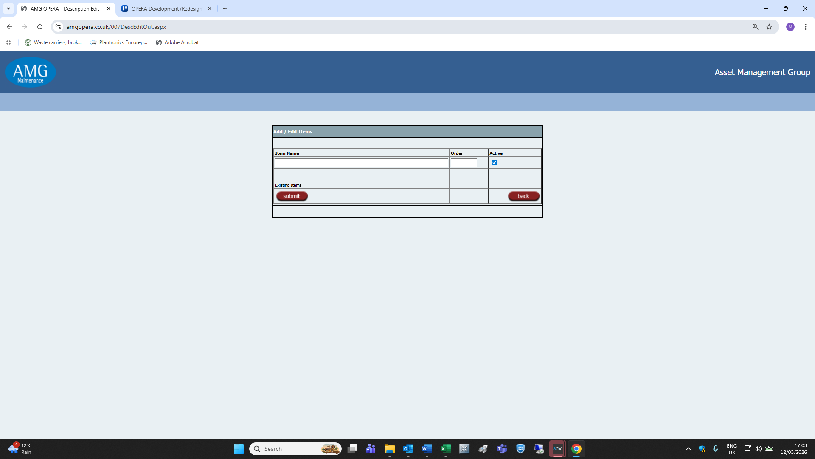

007JobTypeEditOut.aspx
So as to organise the existing items and relegate blank records to the bottom of the table, please add an Order column – between the Code and Type columns – to the Job Types/Codes list below …
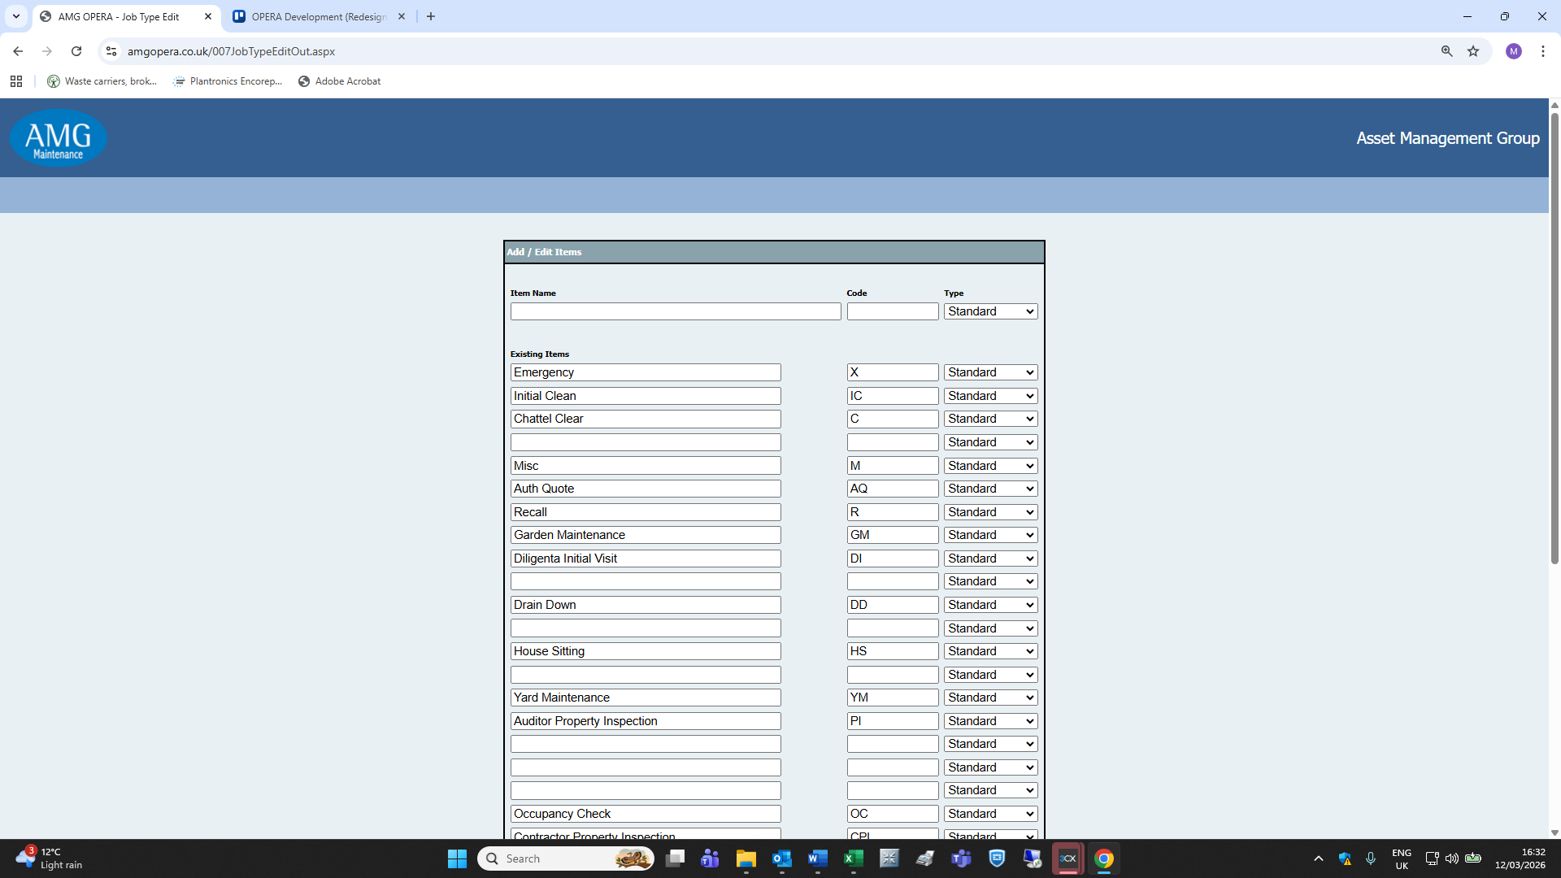
… to match all other lists in the DB Setup section (Invoice Items below as an example)
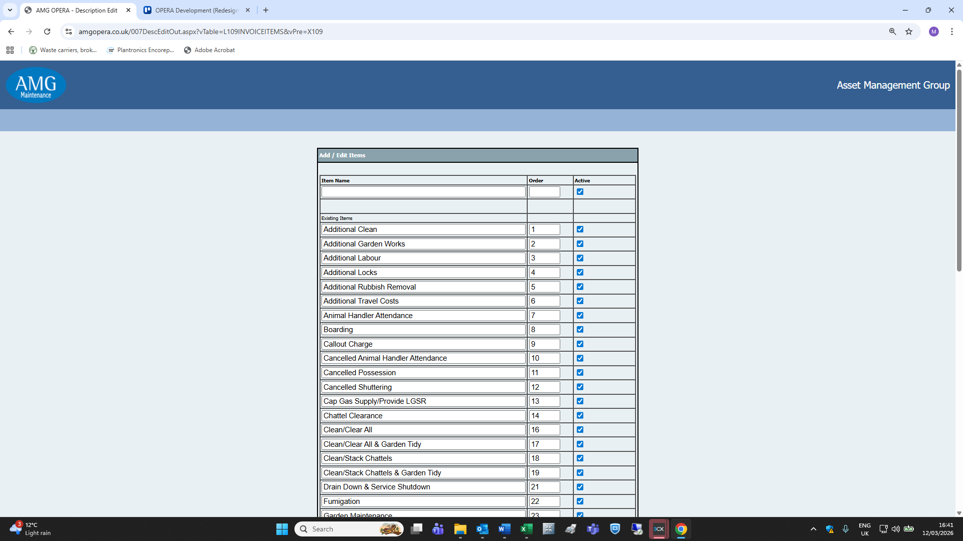

010TalkSheetOut.aspx
No changes required
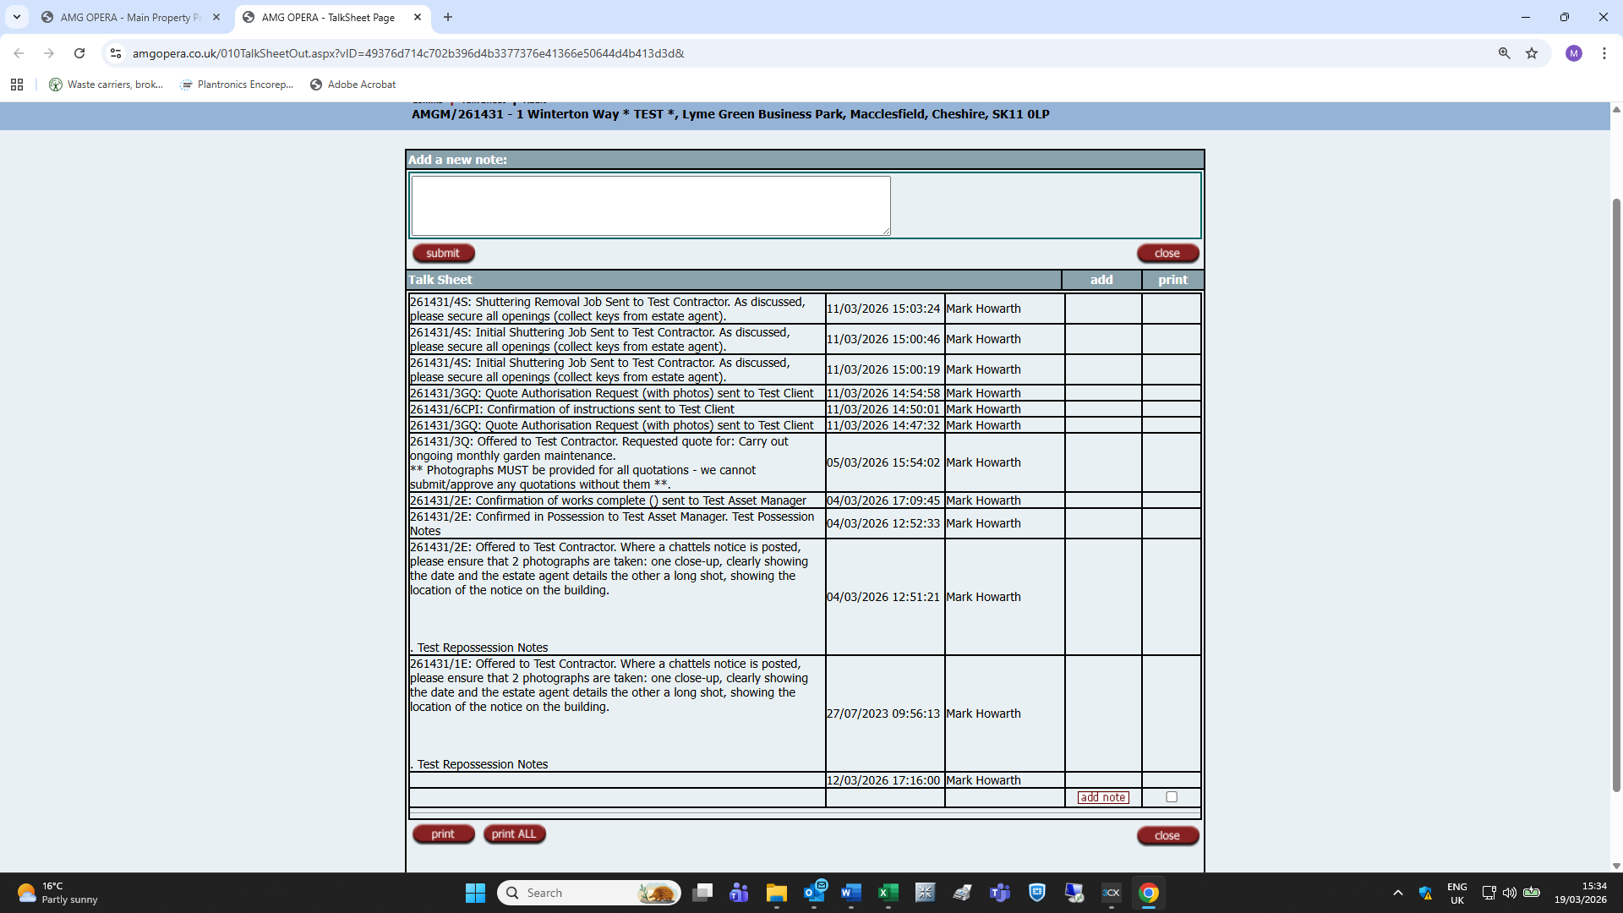

010TalkSheetPrintOut.aspx
Selecting the Print option at the bottom left of the page results in the following error message:
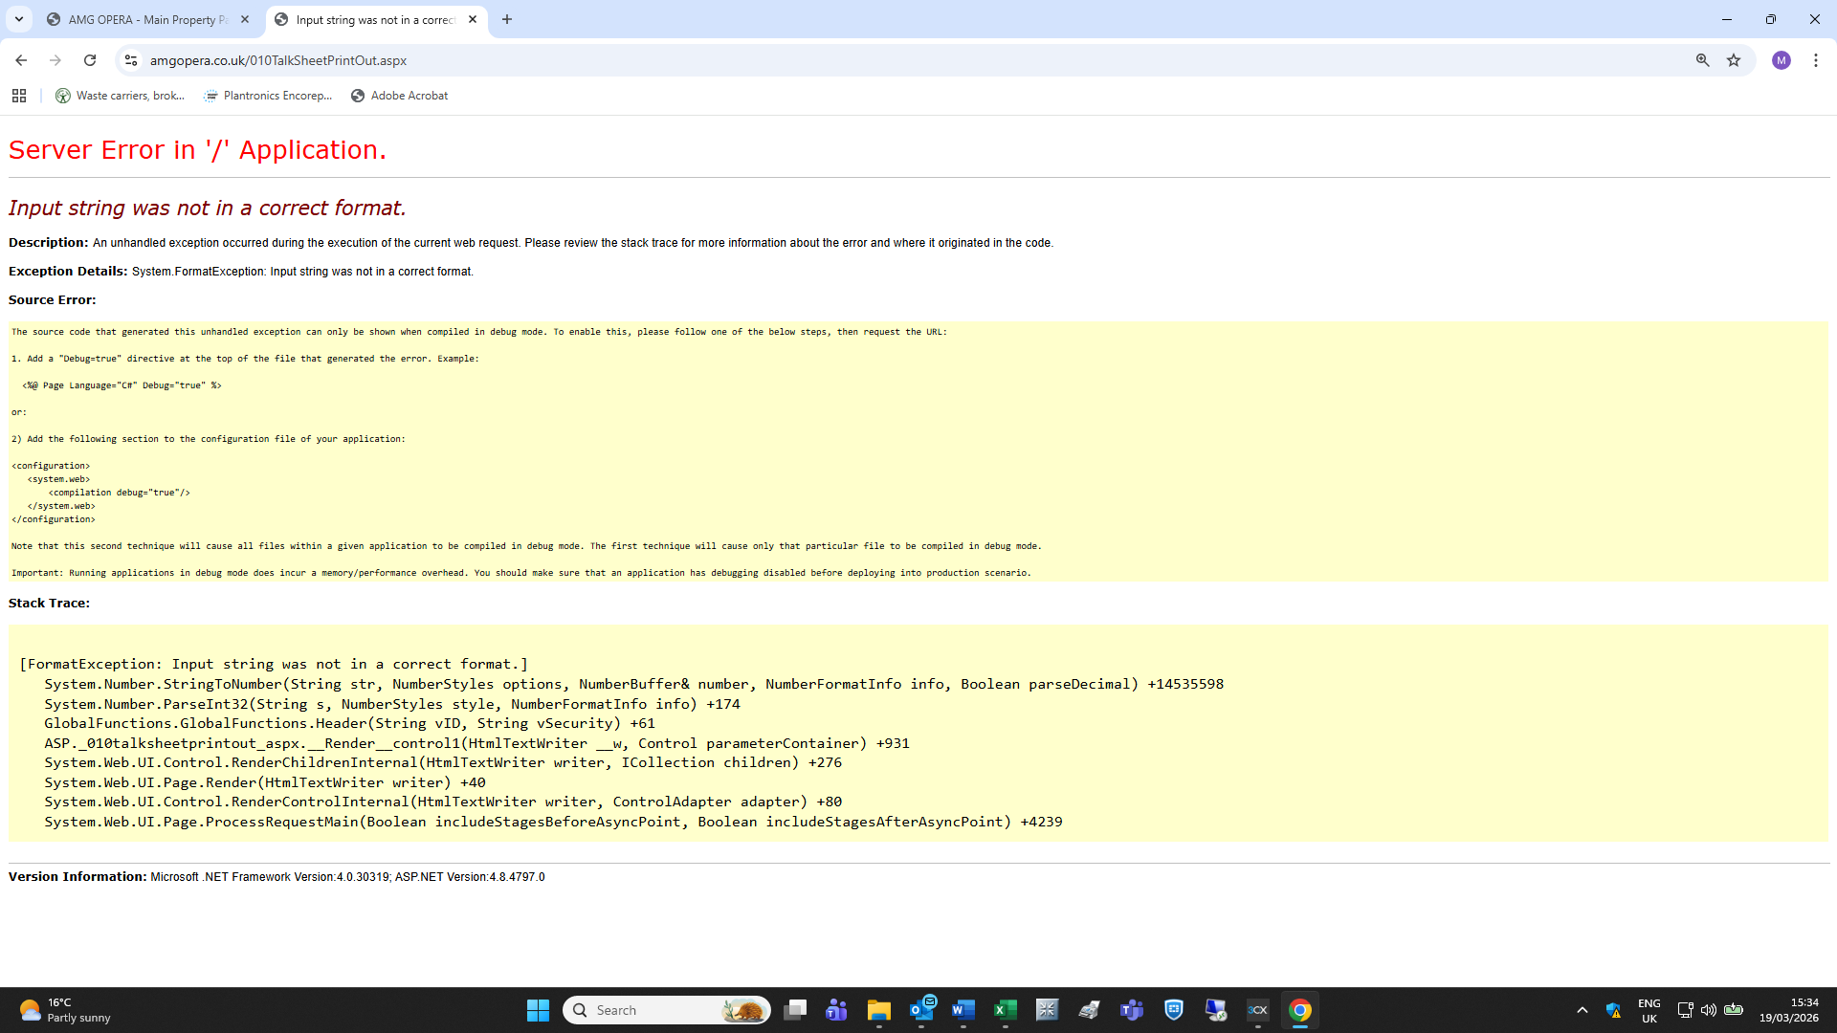

Selecting the Print All option at the bottom left of the page results in a timeout:
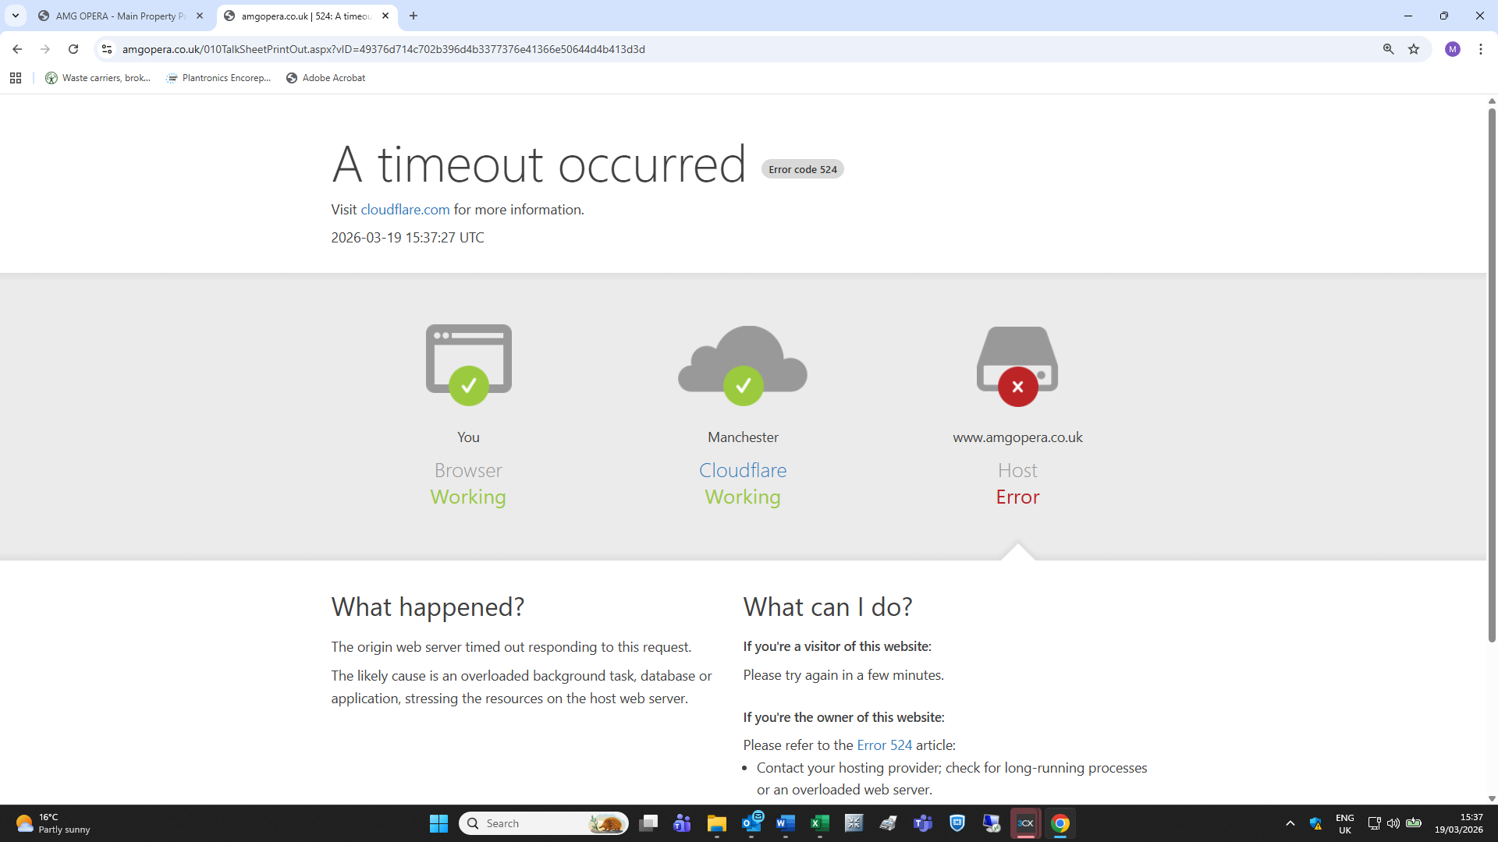
To be honest, I am unsure whether either option has ever worked.

014JobSearchOut.aspx
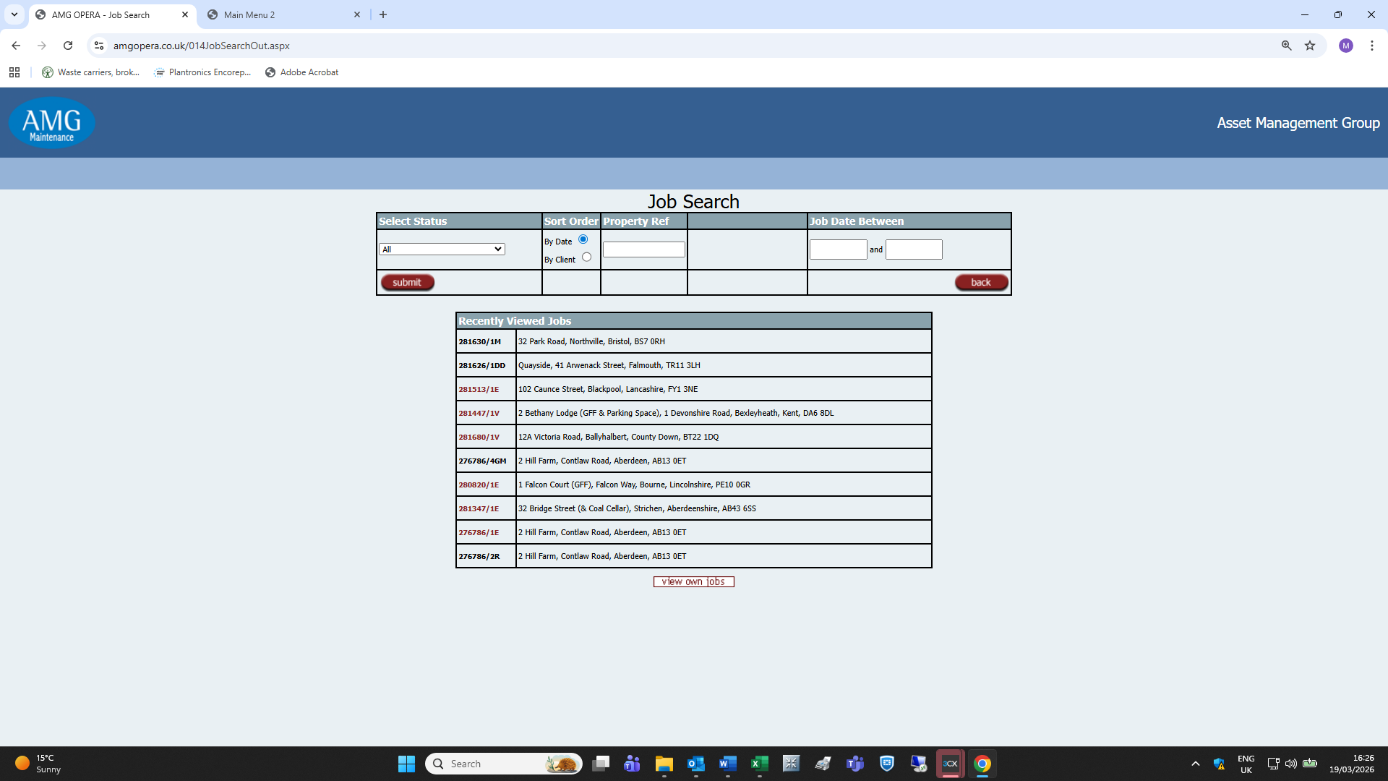
Page may no longer be required – TBC.

014PropertySearchInC.aspx and 014PropertySearchOutC.aspx
Client access pages – to be reviewed later.

014PropertyStatusSummaryOut.aspx
Attempts to reach this page result in the following error message:
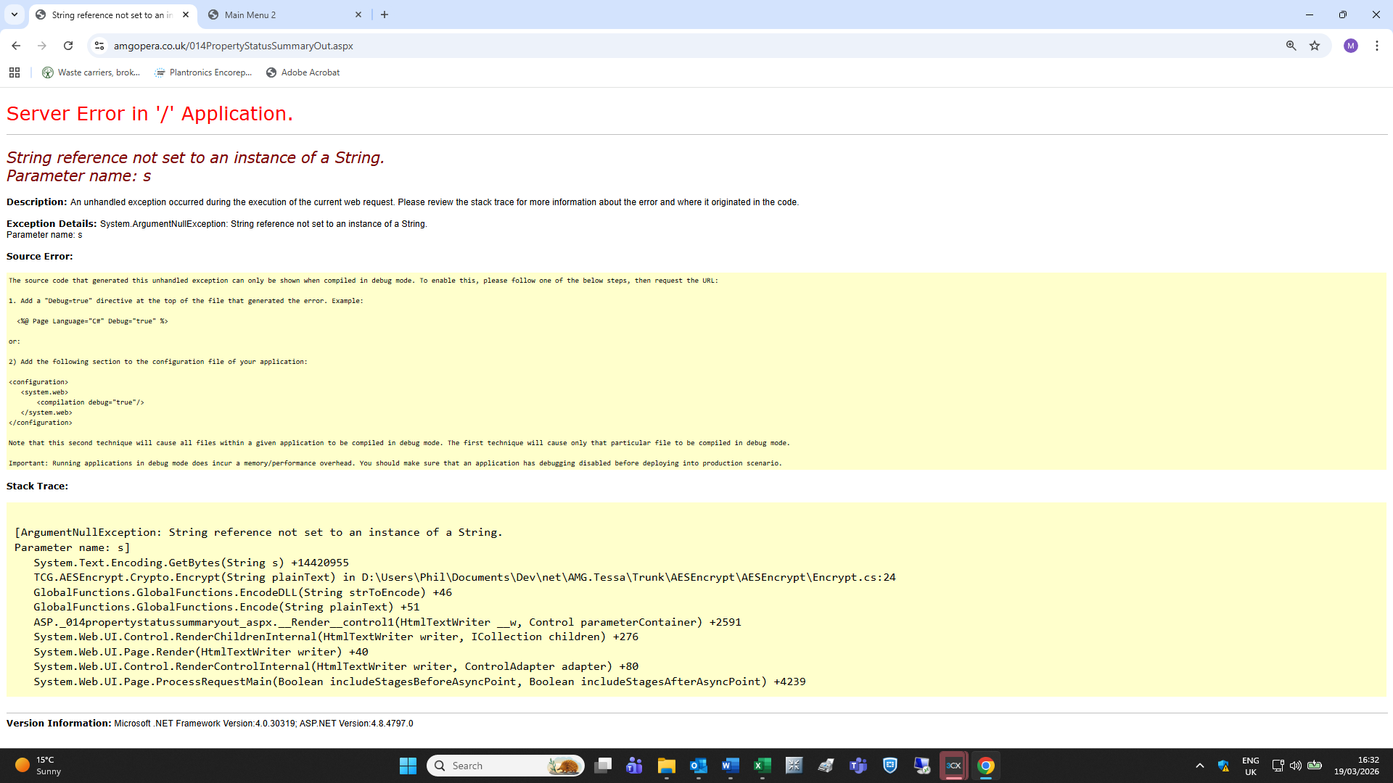

017PostCodeEditOut.aspx
Template:
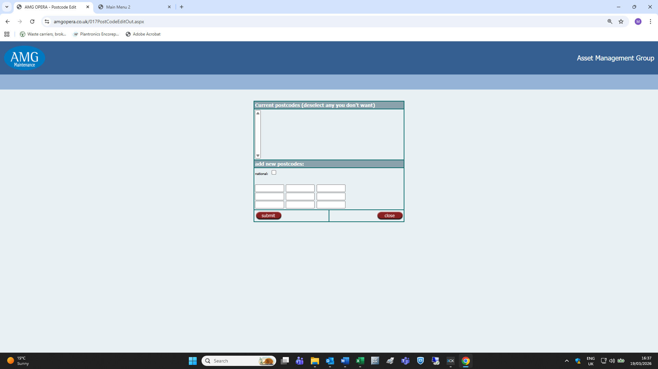
Again, I am unsure if this page has ever been in use on the current version of OPERA.

